

**Software Development Plan**

Sylnder وش

**Version 1.3**

**Presented To:**

**DR. Mohamed Ramadan**

**Submitted By:**

Salma Ali

Marwa Fouad

Mostafa Uosry

Ahmed Abd Elhay

|  |
| --- |
|  |

**Contents**

REVISION HISTORY 2

1. PRODUCT DESCRIPTION 2

2. TEAM DESCRIPTION 2

3. SOFTWARE PROCESS MODEL DESCRIPTION 3

4. PRODUCT DEFINITION 3

5. USER EXPERIENCE WIREFRAMES 8

10

11

6. PROJECT ORGANIZATI 12

PERT Chart 12

7. VALIDATION PLAN 12

The definition of done 12

Test Strategy: 12

8. FEASIBILITY STUDY 13

Risk Identification 13

Risk Prioritization 13

Risk Mitigation 13

9. TOOLS 14

10. ARCHITECTURE 14

# REVISION HISTORY

|  |  |  |  |
| --- | --- | --- | --- |
| **Date** | **Author** | **Distributed to** | **Version** |
| 27/02/24 | All | All | 1.0 |
| 4/03/24 | All | All | 1.1 |
| 28/03/24 | All | All | 1.2 |
| 7/04/24 | All | All | 1.3 |

# PRODUCT DESCRIPTION

Trying to sell or buy a used one in Egypt can sometimes be a challenge, starting from your phone number, there will be many people who are just calling to ask and are not interested in buying, and many of them will try to reduce the price. This is in relation to selling. As for purchasing, trying to find the best price for you, a seller you trust to buy from, and the specifications you dream of are also challenges, so our goal is to make a website that relieves you from all this, complete the sale within 48 hours.

The potential Client for this app would be anyone who trying to buy or sell a used car easily and safely, without any problems.

# 2. TEAM DESCRIPTION

|  |  |  |  |  |
| --- | --- | --- | --- | --- |
|  | Salma ali | Marwa Fouad | Mostafa Uosry | Ahmed Abd elhay |
| Documentation | X | X | X | X |
| Front-end Development | X | X | X | X |
| Back-end Development |  |  | X | X |
| UX/Ui Design | X | X |  |  |
| Research | X | X | X | X |

The skills needed for this project are:

* Collaboration and Communication
* Receiving feedback.
* Project planning
* Subject Matter Expert (SME)
* Experience in programming
* Experience in database management

# 3. SOFTWARE PROCESS MODEL DESCRIPTION

The model chosen for this project is Agile software development.

Agile methodology is well-suited for projects with evolving requirements and a need

for flexibility

# 4. PRODUCT DEFINITION

**Context diagram:**

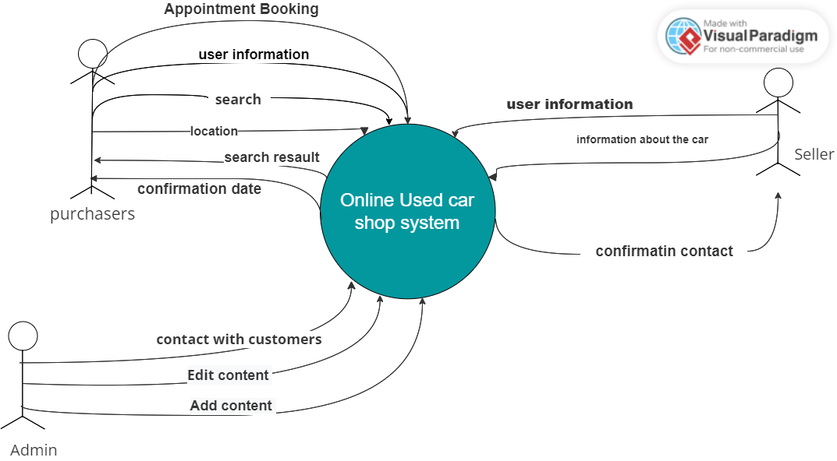

**Use case diagram:**

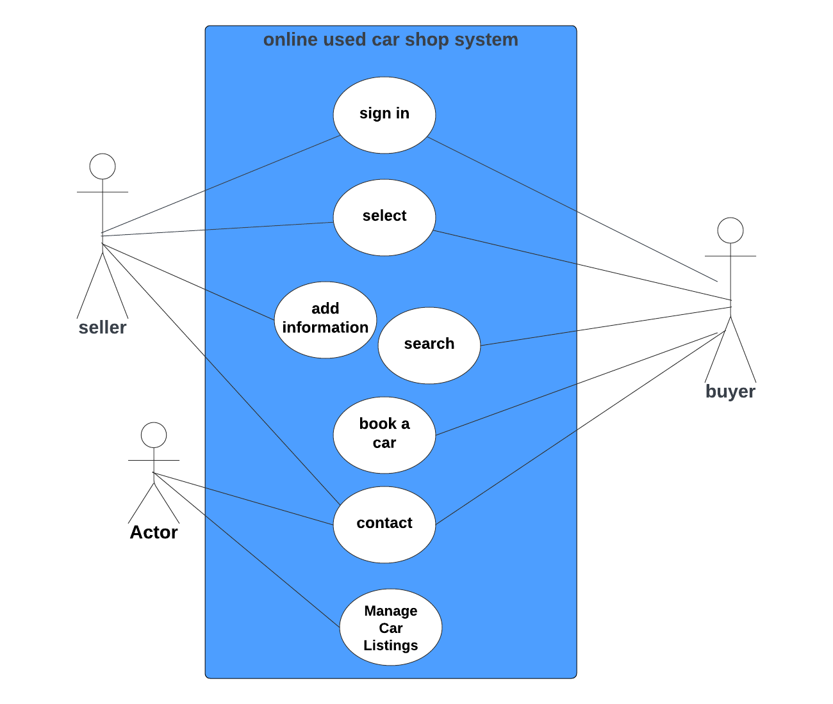

**Admin**

**# Use Case 1: sign in**

**Name: sign in**

**Participating Actor: Customer**

**Entry Conditions: Customer is not registered in the system.**

**Exit Conditions: Customer successfully registered in the system.**

**Flow of Events:**

**Customer accesses the registration page.**

**Customer provides required information (e.g., name, email, password).**

**System validates the information provided.**

**If validation is successful, the system registers the customer and sends a confirmation email.**

**Special Requirements: Customer information should be stored securely.**

**# Use Case 2: select**

**Name: select**

**Participating Actor: Customer**

**Entry Conditions: Customer is logged into the system and viewing car details.**

**Exit Conditions: Transaction is completed successfully.**

**Flow of Events:**

**Customer selects the option to buy or sell the car.**

**Customer provides necessary information for the transaction (e.g., payment details, car details for selling).**

**System processes the transaction and updates the database accordingly.**

**Special Requirements: Secure payment processing for buying, and accurate data handling for selling.**

**# Use Case 3:**

**Name: add information**

**Participating Actor: seller**

**Entry Conditions: seller is logged into the system.**

**Exit Conditions: information about the seller and his car is completed successfully.**

**Flow of Events:**

**Customer selects the option to buy or sell the car.**

**System processes the transaction and updates the database accordingly.**

**Special Requirements: Secure payment processing for buying, and accurate data handling for selling.**

**#Use Case 4: Car Search**

**Name: Car Search**

**Participating Actor: buyer.**

**Entry Conditions: buyer is logged into the system.**

**Exit Conditions: buyer views search results.**

**Flow of Events:**

**Customer accesses the search page.**

**Customer provides search criteria (e.g., make, model, price range).**

**System retrieves relevant car listings based on the provided criteria.**

**Customer views search results.**

**Special Requirements: Efficient search algorithm to retrieve relevant listings quickly.**

**#** **Use Case 5: book a car**

**Name: book a car**

**Participating Actor: Customer**

**Entry Conditions: Customer selects a car from the search results.**

**Exit Conditions: Customer views detailed information about the selected car.**

**Flow of Events:**

**Customer selects a car from the search results.**

**System retrieves and displays detailed information about the selected car (e.g., specifications, photos).**

**Special Requirements: Detailed and accurate information about each car listing.**

**# Use Case 6: contact**

**Name: contact**

**Participating Actor: Admin**

**Entry Conditions: Admin is logged into the system.**

**Exit Conditions: contacting are successfully done.**

**Flow of Events:**

**Admin accesses the admin dashboard.**

**Admin selects the option to view customer contact information.**

**Special Requirements: Access control to ensure only admins can view or cancel reservations.**

**#Use Case 7: Manage Car Listings**

**Name: Manage Car Listings**

**Participating Actor: Admin**

**Entry Conditions: Admin is logged into the system.**

**Exit Conditions: Car listings are successfully managed.**

**Flow of Events:**

**Admin accesses the admin dashboard.**

**Admin selects the option to add, update, or delete a car listing.**

**Admin provides necessary information for the selected action.**

**System updates the database accordingly.**

**Special Requirements: Authorization and access control to ensure only admins can manage car listings.**

# 5. USER EXPERIENCE WIREFRAMES

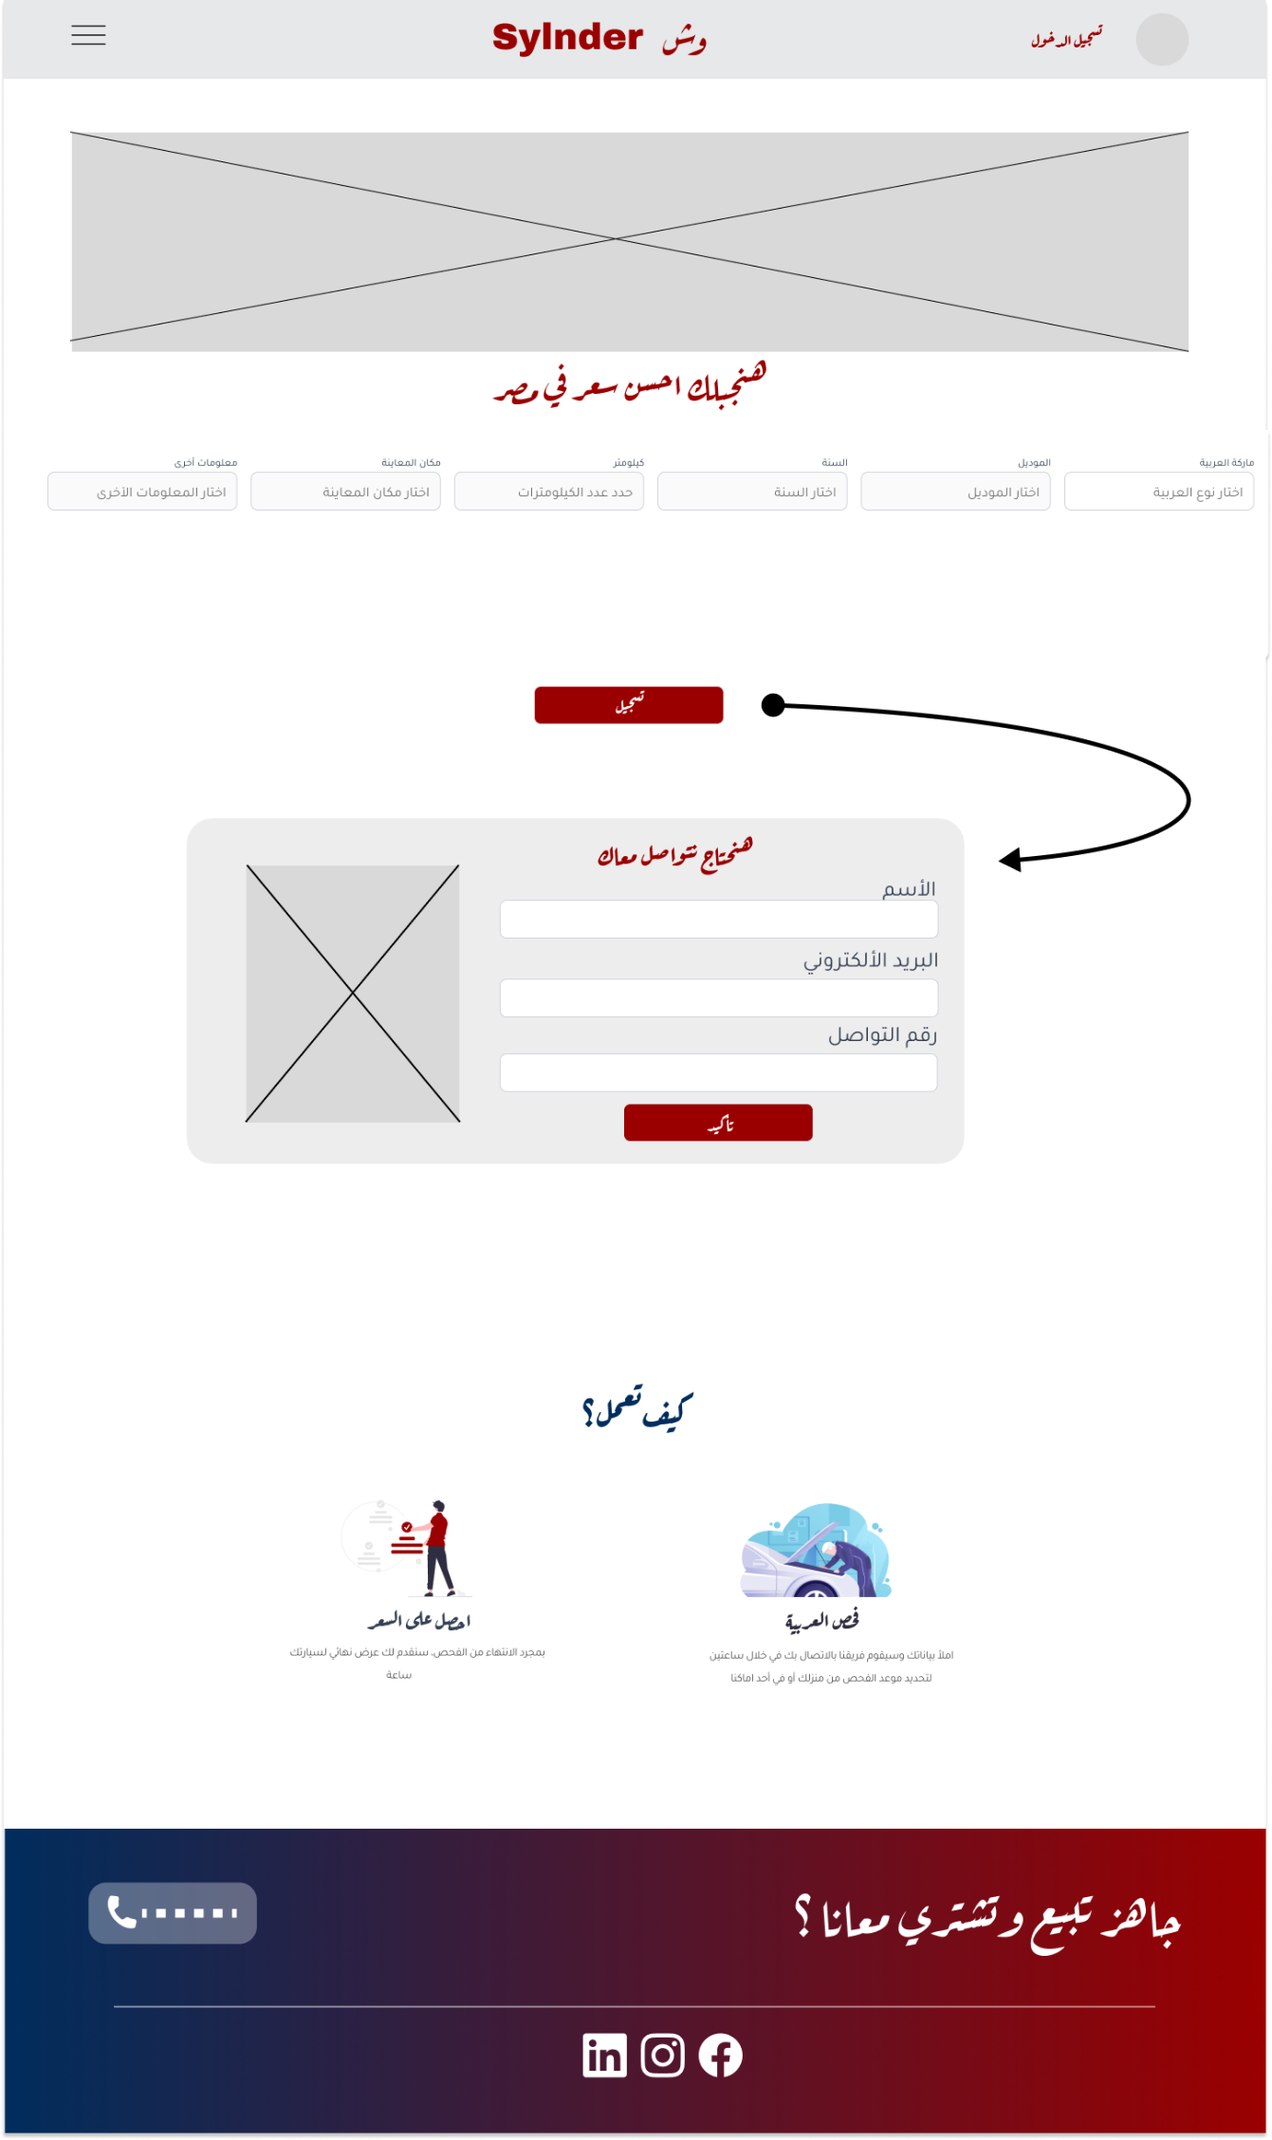

# 

# 

# 6. PROJECT ORGANIZATI

# PERT Chart

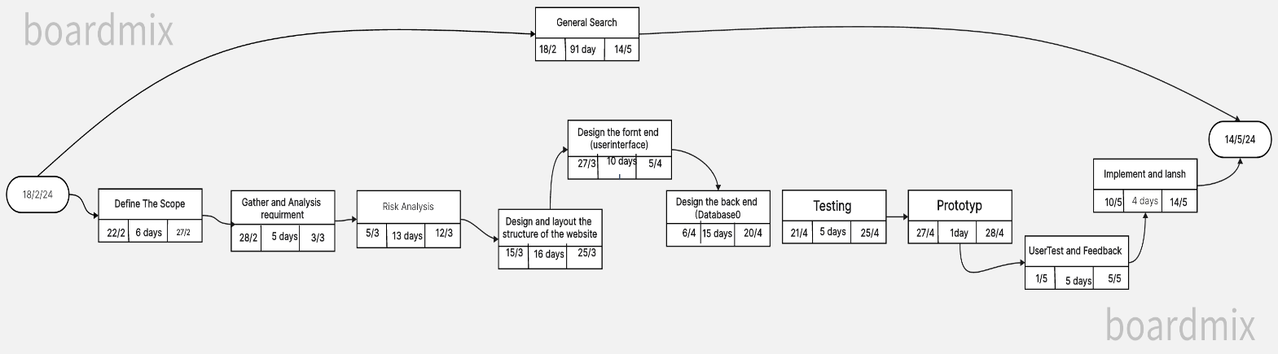

# 7. VALIDATION PLAN

**Objective:**

Ensure that the Wish Slender website meets specified requirements and provides a smooth and safe user experience.

**Scope:**

Verification activities will cover the following aspects of the site:

1. User registration and authentication

2. List cars for sale

3. Search for cars, make purchases, and process payment

4.Verify website compatibility across different browsers (Chrome, Firefox, Safari, etc.) and devices (desktop, mobile, tablet).

**Verification strategy:**

All verifications will be done through

Combination of manual and automated testing method:

Test team

Exploratory testing, user flow validation and real-world scenarios will be conducted to validate the websites' functionality, performance, security and usability.

## The definition of done

The definition of "done" this project involves meeting all requirements within the specified timeframe and providing users with a seamless experience for buying or selling cars. Success is defined by the ability of a user to effectively find a desired car listing and complete a transaction smoothly.

## Test Strategy:

**Our main test plan will be as follows:**

* User Registration:

Create both buyer and seller accounts.

Verify the registration process for ease of use and accuracy of information capture.

* Listing Details:

Verify that detailed information about each car listing is displayed accurately.

* Ensure images, descriptions, specifications, and seller contact information are accessible and accurate.
* Test

the website's functionality and usability across various devices and screen sizes.

Ensure the user experience remains consistent and intuitive on mobile devices.

* User Feedback:

Gather user feedback through surveys or feedback forms to identify areas for improvement.

Use feedback to iterate and enhance the website's usability and functionality.

# 8. FEASIBILITY STUDY

## Risk Identification

* Lack of visibility: The biggest risk is not getting enough visibility for the site, which leads to lower user adoption and usage.
* Security vulnerabilities: Insecure data storage and vulnerabilities in handling user input pose a significant risk to the privacy and security of user data.
* Failure to provide comprehensive information: If a website fails to compile and provide comprehensive information about cars for sale, it may not serve as a reliable central platform for users.
* Lack of experience in web development: The relative lack of experience of the team in web development may pose a threat to the success of project implementation, especially in learning the new technologies and languages ​​required for development.

## Risk Prioritization

* + - 1. Lack of vision
      2. Security vulnerabilities
      3. Failure to provide comprehensive information

## Risk Mitigation

* Promotion and Advertising: Implement a strong marketing strategy to promote the website, and use targeted advertising and partnerships with relevant automotive platforms to increase visibility.
* Security measures: Regular security audits and penetration tests should be conducted to identify and mitigate intrusions
* And encryption of sensitive information.
* Training and Skills Development: Provide training and resources to the development team to enhance their proficiency in web development technologies and languages. Encourage continuous learning and collaboration with experienced developers to mitigate risks associated with lack of experience.
* Comprehensive information: Ensure that the site collects comprehensive and accurate information about cars for sale by expanding data sources, enhancing data validation processes

# 9. TOOLS

**Database management system:**

MySQL, PostgreSQL

Database systems for storing website data such as user profiles, car listings, and transactions.

1. **Web development frameworks:**

**Frontend:**

HTML, CSS, and JavaScript to build the user interface and frontend functionality.

**Backend:**

Node.js and Express.jsor for developing server-side logic and APIs and handling database interactions.

**3. Integrated Development Environment (IDE):**

Visual Studio Code, for coding, debugging, and testing website components.

**4. Web Scraping Tools:**

Beautiful Soup, Scrapy, to collect data from external sources such as car dealership websites.

# 10. ARCHITECTURE

**Devices for testing:**

1. **Desktop computers:**

Windows, macOS, and Linux to test website functionality and compatibility across different operating systems and browsers.

**Mobile Devices:**

Android smartphones and tablets, iPhones and iPads to test mobile responsiveness and compatibility.

1. **Servers and hosting environment:**

Dedicated or cloud servers to host the website and database.

Consider scalable hosting solutions to accommodate potential increases in traffic.

1. **Programming Languages and Technologies:**

HTML, CSS, JavaScript, and frameworks/libraries for frontend development.

Backend programming languages such as JavaScript (Node.js),